(a) Find the three hidden flows using conservation of flow (4 marks)
Ayesha Siddiqa S
192324305 (Roll No 4)
Flow conservation: Incoming flow = outgoing flow at each node.
- Search engine → Genre page
Search engine total = 1,310
Known outgoing flows: 524 + 393 = 917
Missing flow = 1,310 − 917 = 393 sessions
- Partner blog → Bestsellers page
Partner blog total = 1,415
Known outgoing flows: 495 + 0 + 495 = 990
Missing flow = 1,415 − 990 = 425 sessions
- Exit site → No order
Exit site total = 1,116
Known outgoing flows: 825 + 332 = 1,157
This gives a negative missing flow, so the diagram's values are inconsistent or one of the labels has been misread. Please verify the Exit site node and its outgoing flow labels before submitting this part.
(b) Conversion rate and percentages (4 marks)
Total sessions = 5,240.

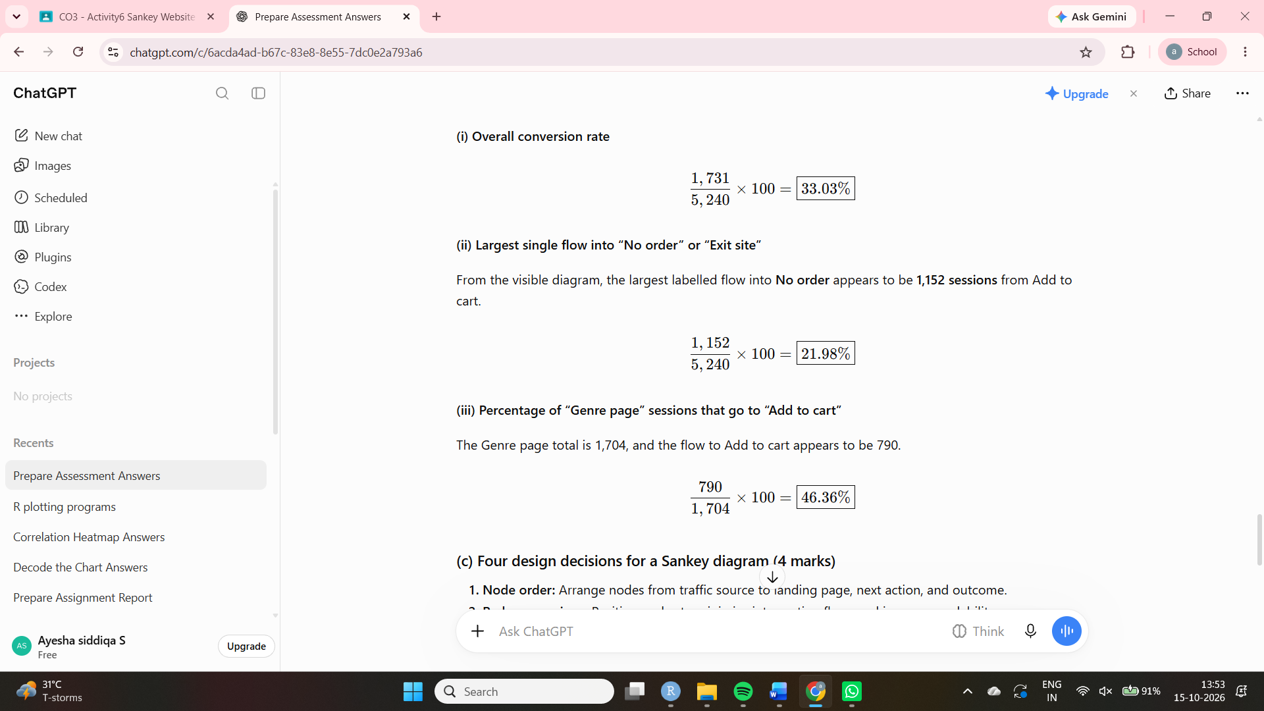

(c) Four design decisions for a Sankey diagram (4 marks)
- Node order: Arrange nodes from traffic source to landing page, next action, and outcome.
- Reduce crossings: Position nodes to minimise intersecting flows and improve readability.
- Colour: Use consistent colours for traffic sources or flow categories.
- Highlight: Emphasise important flows, such as those leading to an order or a site exit.
(d) Landing-page node heights (2 marks)
Scale: 1 cm = 300 sessions.
Landing page | Sessions | Height
Home page | 1,874 | \(1874/300=\) 6.25 cm
Genre page | 1,704 | \(1704/300=\) 5.68 cm
Bestsellers page | 1,662 | \(1662/300=\) 5.54 cm
(e) R code for the first four flows leaving Search engine and Partner blog (4 marks)
library(networkD3)
flows <- data.frame(
source = c("Search engine", "Search engine",
"Partner blog", "Partner blog"),
target = c("Genre page", "Bestsellers page",
"Home page", "Bestsellers page"),
value = c(393, 393, 495, 425)
)
nodes <- data.frame(
name = unique(c(flows$source, flows$target))
)
flows$IDsource <- match(flows$source, nodes$name) - 1
flows$IDtarget <- match(flows$target, nodes$name) - 1
sankeyNetwork(
Links = flows,
Nodes = nodes,
Source = "IDsource",
Target = "IDtarget",
Value = "value",
NodeID = "name",
fontSize = 12,
nodeWidth = 25
)
(f) Two situations where a Sankey diagram misleads (2 marks)
- Too many flows and crossings: The diagram becomes cluttered and difficult to follow. Use a heatmap or a flow table instead.
- Large differences in flow sizes: Small flows become hard to see beside dominant flows. Use a sorted bar chart to compare the values clearly.

